WEEK 2 INTERNSHIP REPORT
Data Visualization and Insight Communication using R
Spotify Most Streamed Songs 2025 Dataset

Intern | Bala Gayatri
Internship | YuvaIntern – NSDC
Week | Week 2
Technology | R / RStudio (Posit Cloud)
Dataset | Most Streamed Spotify Songs 2025

- Executive Summary
This report presents the Week 2 internship work completed under the YuvaIntern program with a focus on data visualization and insight communication using R. The Most Streamed Spotify Songs 2025 dataset used in Week 1 was continued so that the visualization stage could build directly on the previously cleaned and explored data. The objective of this week was to create informative visualizations, select appropriate chart types, explain their significance, and communicate analytical findings in a form understandable to both technical and non-technical audiences. Using R, ggplot2, and base plotting functions, multiple visualizations were developed to examine song popularity, artist representation, streaming distributions, collaboration patterns, relationships between daily and total streams, and the concentration of streaming activity. The visual analysis reinforces important findings from Week 1, including the strong positive relationship between daily streams and total Spotify streams, the high representation of certain artists, and the relatively small proportion of collaborations. Each visualization is supported by R code, an output placeholder, an explanation of why the chart was selected, and an interpretation of the insight communicated.

2.Table of Contents

1. Executive Summary
2. Table of Contents
3. Screenshot Checklist
4. Objectives
5. Dataset Overview
6. Tools and Visualization Approach
7. Visualizations and Insight Communication
8. Comparative Visualization Analysis
9. Key Insights Communicated Through Visualization
10. Visualization Design Principles
11. R Code Appendix
12.Conclusion

3.ScreenShot Checklist

S. No. | Screenshot / Visual Evidence | Where to Insert
1 | RStudio/Posit Cloud showing the imported Spotify dataset | Dataset Overview
2 | Top 10 Most Streamed Songs bar chart | Section 7.1
3 | Top 10 Artists by Number of Songs bar chart | Section 7.2
4 | Distribution of Daily Streams histogram | Section 7.3
5 | Daily Streams vs Total Spotify Streams scatter plot | Section 7.4
6 | Collaboration vs Non-Collaboration Songs bar chart | Section 7.5
7 | Top 10 Artists by Total Spotify Streams bar chart | Section 7.6
8 | Top 10 Songs by Daily Stream Share bar chart | Section 7.7
9 | Correlation Heatmap | Section 7.8

4. Objectives
- Create multiple informative visualizations using R.
- Use appropriate chart types to communicate comparisons, distributions, relationships and patterns.
- Explain the purpose and significance of each visualization.
- Communicate insights clearly to a non-technical audience.
- Demonstrate technically accurate and reproducible R visualization code.
- Build upon the cleaned Spotify dataset prepared during Week 1.

5. Dataset Overview
The Most Streamed Spotify Songs 2025 dataset contains 730 observations representing highly streamed songs. Important variables used for visualization include track, artist, total Spotify streams, daily streams, daily stream share percentage, billed artist count, collaboration status and ranking-related variables. The dataset is suitable for visualization because it contains substantial variation in streaming performance and meaningful categorical groupings that allow comparisons among songs and artists.

Variable | Type | Visualization Use
track | Categorical | Song-level comparisons
artist | Categorical | Artist-level comparisons
spotify_streams_total | Numeric | Popularity and total-stream analysis
daily_streams | Numeric | Current streaming activity
daily_stream_share_pct | Numeric | Contribution to daily streams
is_collaboration | Categorical/Binary | Collaboration comparison

6. Tools and Visualization Approach
The visualizations were developed in R using ggplot2 through the tidyverse package. ggplot2 was selected because it provides a consistent grammar for constructing charts and makes it possible to control titles, labels, axes, ordering and geometric elements. Base R plotting was also used where a simple distribution view was appropriate.
library(tidyverse)
library(corrplot)
spotify_original <- read.csv("most_streamed_spotify_2025.csv")

7. Visualizations and Insight Communication
The visualizations were selected to cover ranking and comparison, distribution, composition, relationships and concentration of streaming activity. Different chart types were used according to the analytical question rather than for visual variety alone.
7.1 Top 10 Most Streamed Songs
R Code
top_10_songs <- spotify_original %>%
arrange(desc(spotify_streams_total)) %>%
select(track, artist, spotify_streams_total) %>%
head(10)
ggplot(top_10_songs,
aes(x = reorder(track, spotify_streams_total),
y = spotify_streams_total)) +
geom_col() +
coord_flip() +
labs(title = "Top 10 Most Streamed Songs",
x = "Song", y = "Total Spotify Streams")
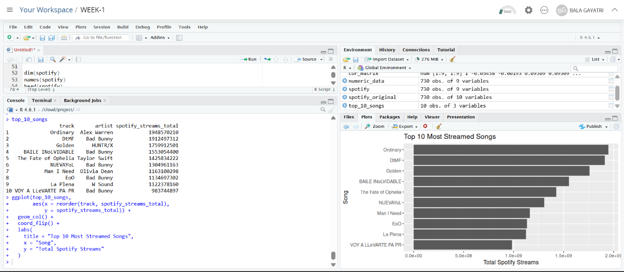
5.1 Top 10 Most Streamed Songs
Why this visualization was selected:
A horizontal bar chart is appropriate for comparing discrete songs using one numerical measure. coord_flip() improves readability of long song titles.
Interpretation and insight:
The chart identifies the highest-performing songs. Ordinary by Alex Warren leads with approximately 1.95 billion streams, while several other songs also exceed one billion streams, showing strong concentration among the most successful tracks.

7.2 Top 10 Artists by Number of Songs
R Code
top_artists <- spotify_original %>%
count(artist, sort = TRUE) %>%
head(10)
ggplot(top_artists,
aes(x = reorder(artist, n), y = n)) +
geom_col() + coord_flip() +
labs(title = "Top 10 Artists by Number of Songs",
x = "Artist", y = "Number of Songs")
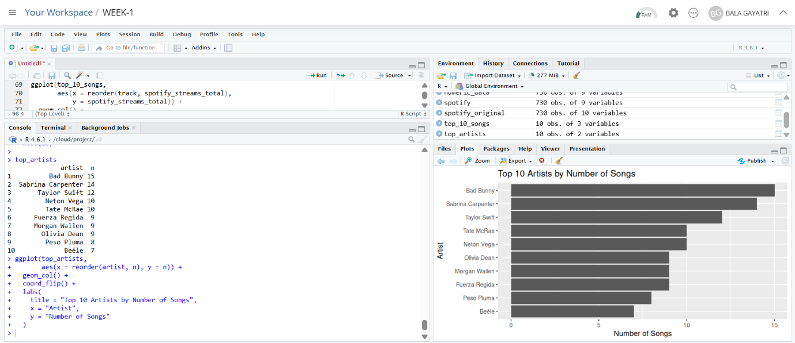
5.2 Top 10 Artists by Number of Songs
Why this visualization was selected:
A horizontal bar chart allows artist names to remain readable while making differences in song counts easy to compare.
Interpretation and insight:
Bad Bunny has the highest representation with 15 songs, followed by Sabrina Carpenter with 14 and Taylor Swift with 12. This indicates that several artists have multiple successful entries in the dataset.
7.3 Distribution of Daily Streams
R Code
hist(spotify_original$daily_streams,
main = "Distribution of Daily Streams",
xlab = "Daily Streams")
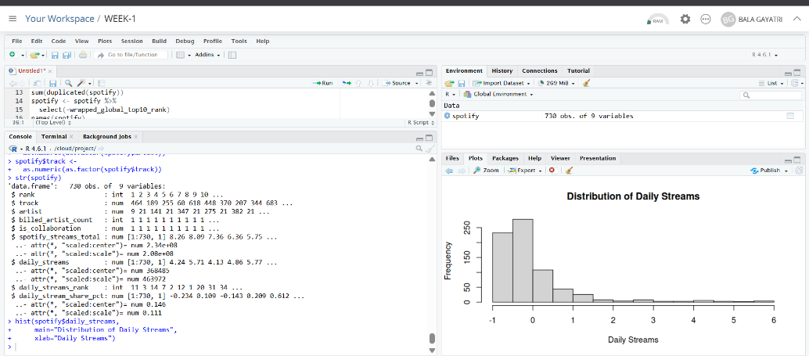
5.3 Distribution of Daily Streams
Why this visualization was selected:
A histogram is suitable for examining the distribution of a continuous numerical variable and identifying concentration, spread and skewness.
Interpretation and insight:
The distribution demonstrates that daily streaming activity is uneven. A relatively small number of songs receive substantially higher daily streams than many other songs, reflecting concentration in streaming popularity.
7.4 Daily Streams vs Total Spotify Streams
R Code
ggplot(spotify_original,
aes(x = daily_streams, y = spotify_streams_total)) +
geom_point() +
labs(title = "Daily Streams vs Total Spotify Streams",
x = "Daily Streams", y = "Total Spotify Streams")
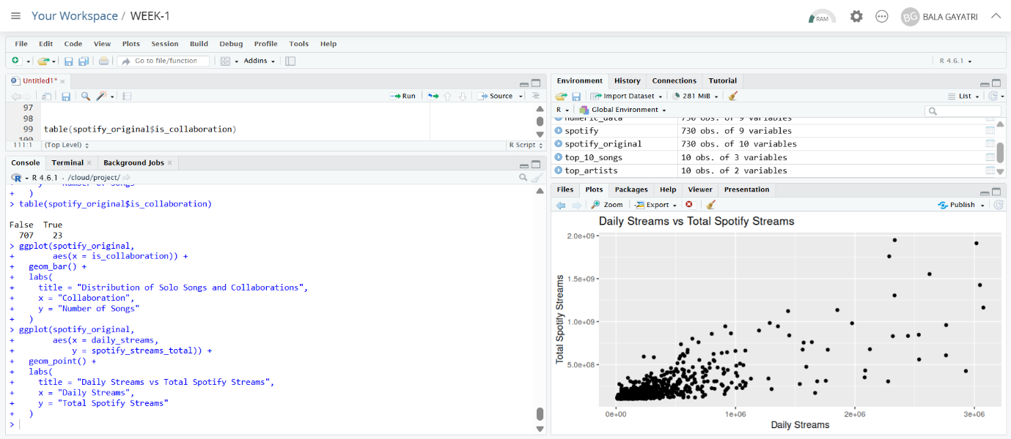
5.4 Daily Streams vs Total Spotify Streams
Why this visualization was selected:
A scatter plot is appropriate for examining the relationship between two continuous numerical variables. Each point represents a song.
Interpretation and insight:
The plot shows a clear positive relationship: songs with higher daily streams generally have higher accumulated total streams. This visual pattern agrees with the Week 1 correlation coefficient of 0.7795761.

7.5 Collaboration vs Non-Collaboration Songs
R Code
ggplot(spotify_original,
aes(x = is_collaboration)) +
geom_bar() +
labs(title = "Distribution of Solo Songs and Collaborations",
x = "Collaboration", y = "Number of Songs")
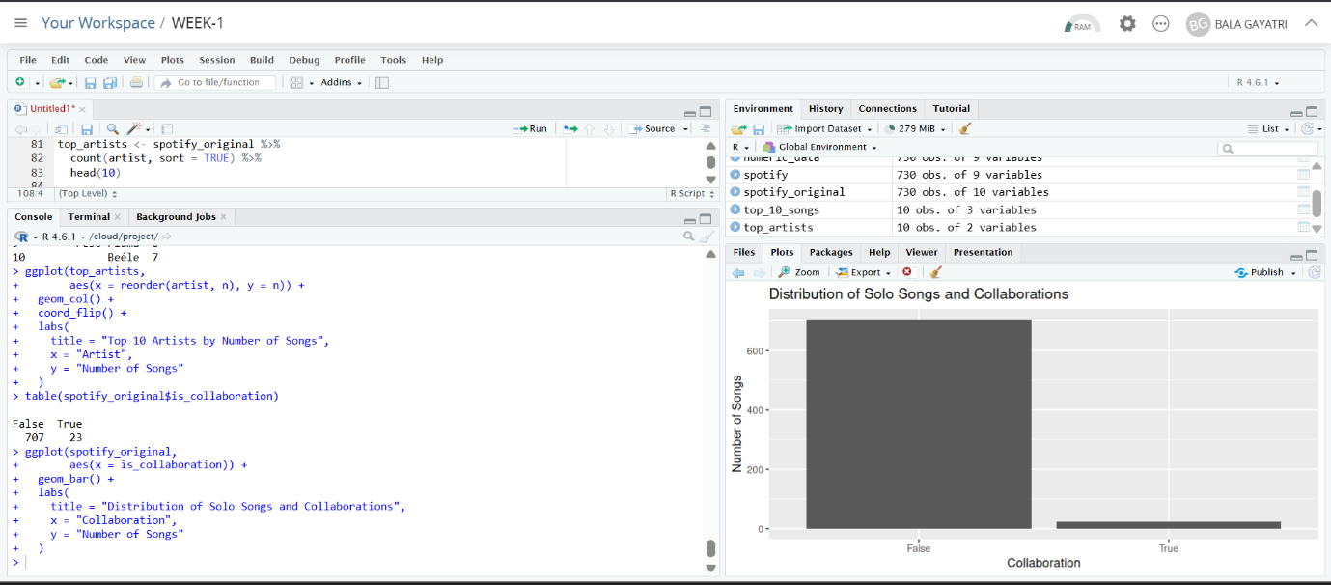
5.5 Collaboration vs Non-Collaboration Songs
Why this visualization was selected:
A bar chart is effective for comparing the frequency of categorical groups.
Interpretation and insight:
The dataset contains 707 non-collaboration songs and 23 collaboration songs. Collaborations therefore form a relatively small proportion of the selected songs.

7.6 Top Artists by Total Spotify Streams
R Code
artist_streams <- spotify_original %>%
group_by(artist) %>%
summarise(total_streams = sum(spotify_streams_total, na.rm = TRUE)) %>%
arrange(desc(total_streams)) %>%
head(10)
ggplot(artist_streams,
aes(x = reorder(artist, total_streams), y = total_streams)) +
geom_col() + coord_flip() +
labs(title = "Top 10 Artists by Total Spotify Streams",
x = "Artist", y = "Combined Spotify Streams")
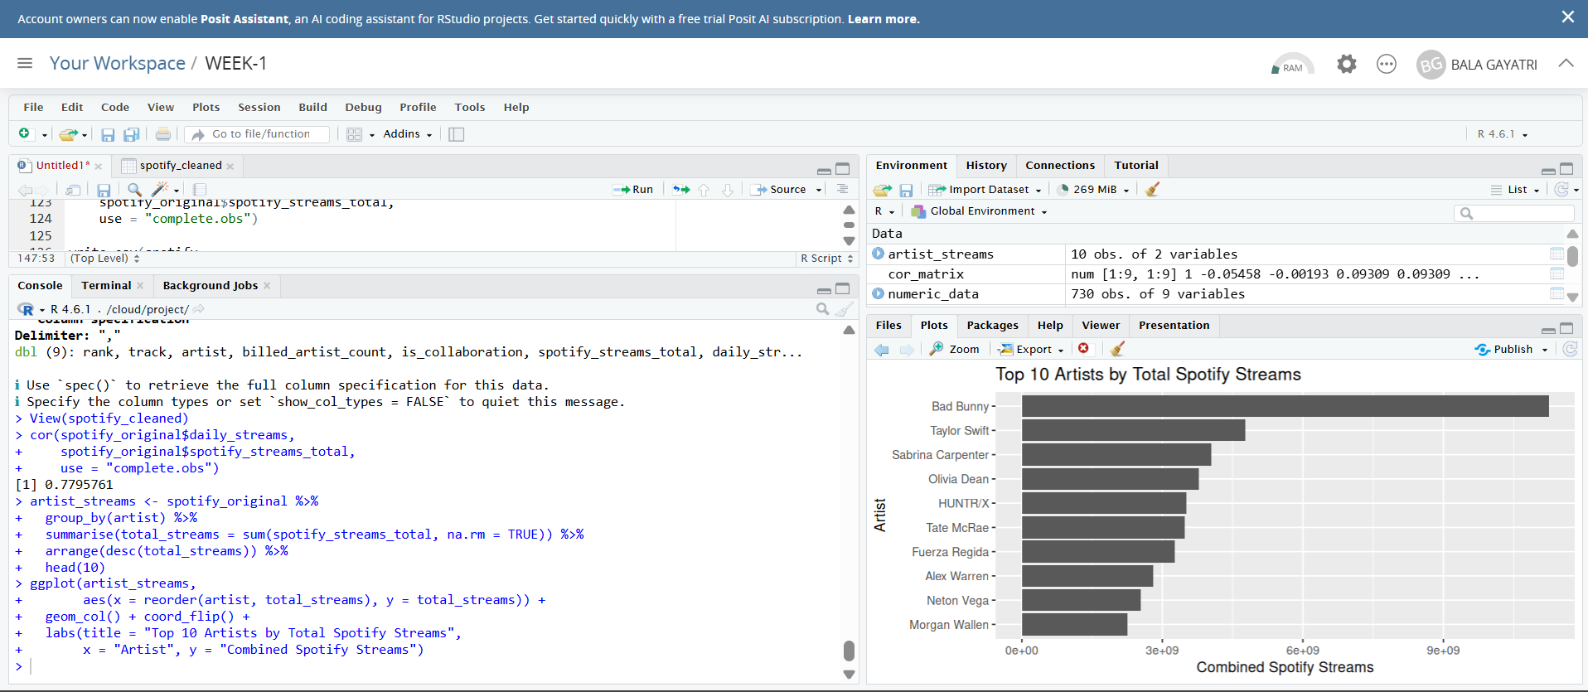
5.6 Top Artists by Total Spotify Streams
Why this visualization was selected:
Aggregating streams by artist measures cumulative streaming impact across an artist's songs rather than focusing on only one track. A bar chart provides a direct comparison.
Interpretation and insight:
This chart provides an artist-level view of cumulative performance. It can reveal artists whose overall impact is large because several songs perform strongly, complementing the single-song rankings.

7.7 Top Songs by Daily Stream Share
R Code
top_daily_share <- spotify_original %>%
arrange(desc(daily_stream_share_pct)) %>%
select(track, artist, daily_stream_share_pct) %>%
head(10)
ggplot(top_daily_share,
aes(x = reorder(track, daily_stream_share_pct),
y = daily_stream_share_pct)) +
geom_col() + coord_flip() +
labs(title = "Top 10 Songs by Daily Stream Share",
x = "Song", y = "Daily Stream Share (%)")

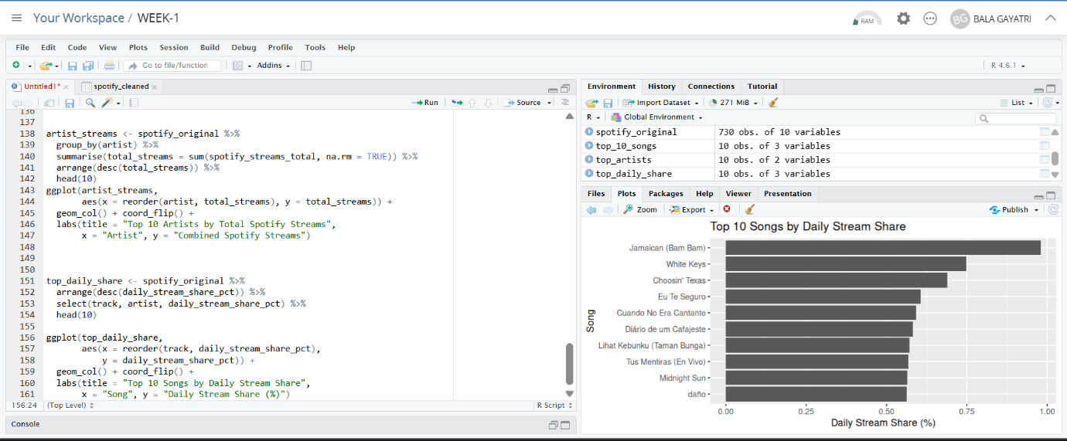
5.7 Top Songs by Daily Stream Share
Why this visualization was selected:
A ranked bar chart is suitable for a percentage measure and clearly shows which songs contribute the largest shares of daily streaming activity.
Interpretation and insight:
This visualization provides a current-activity perspective. It complements total-stream rankings because a song's accumulated streams and its current share of daily activity do not necessarily represent the same thing.
7.8 Correlation Heatmap
R Code
numeric_data <- spotify %>%
select(where(is.numeric))
cor_matrix <- cor(numeric_data)
corrplot(cor_matrix method="color")
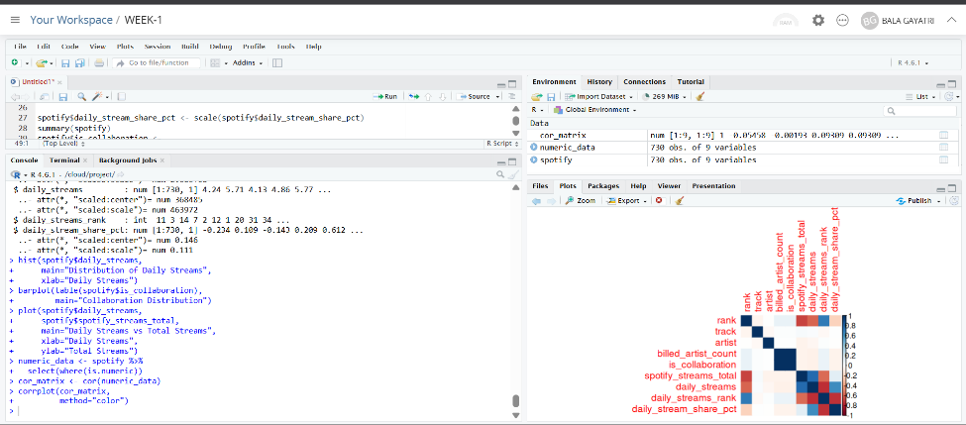
5.8 Correlation Heatmap
Why this visualization was selected:
A correlation heatmap allows several numerical variables to be compared simultaneously. Color intensity provides a compact visual representation of relationship strength.
Interpretation and insight:
The heatmap helps identify numerical variables that move together. The relationship between daily streams and total Spotify streams is particularly important and supports the detailed scatter-plot and correlation analysis.

8. Comparative Visualization Analysis
Taken together, the visualizations communicate different aspects of the Spotify dataset rather than repeating the same information. The ranked bar charts focus on comparison and identify songs and artists with the strongest representation or performance. The histogram focuses on distribution and demonstrates that streaming activity is uneven. The scatter plot communicates the relationship between current and accumulated streaming performance, while the collaboration chart communicates the composition of the dataset. The artist-level aggregation and daily-stream-share visualizations provide alternative perspectives that cannot be obtained from a simple top-10 ranking. Finally, the correlation heatmap provides a compact overview of relationships among numerical variables.

9. Key Insights Communicated Through Visualization
Streaming performance is highly concentrated among a relatively small group of songs.
Ordinary by Alex Warren is the highest-streamed song in the dataset, with approximately 1.95 billion total streams.
Bad Bunny has the largest number of songs represented among the top artists, with 15 entries.
Daily streams and total Spotify streams show a strong positive relationship, consistent with the correlation value of 0.7795761.
Non-collaboration songs substantially outnumber collaboration songs, with 707 versus 23 observations.
Artist-level analysis provides a broader view of performance than single-song rankings because it captures cumulative activity across multiple songs.
Daily stream share provides a current-activity perspective that complements accumulated total-stream rankings.

10. Visualization Design Principles
Chart types were selected according to the question being answered.
Horizontal bars were used where long song or artist names needed to remain readable.
Scatter plots were used for relationships between continuous variables.
Histograms were used to communicate distributions rather than rankings.
Titles and axis labels were included so charts can be understood without referring to the code.
Every visualization is accompanied by an interpretation to make the analysis accessible to a non-technical audience.

11. R Code Appendix
library(tidyverse)
library(corrplot)
spotify_original <- read.csv("most_streamed_spotify_2025.csv")
# Top 10 songs
top_10_songs <- spotify_original %>%
arrange(desc(spotify_streams_total)) %>%
select(track, artist, spotify_streams_total) %>% head(10)
ggplot(top_10_songs, aes(x=reorder(track, spotify_streams_total), y=spotify_streams_total)) +
geom_col() + coord_flip() +
labs(title="Top 10 Most Streamed Songs", x="Song", y="Total Spotify Streams")
# Top 10 artists
top_artists <- spotify_original %>% count(artist, sort=TRUE) %>% head(10)
ggplot(top_artists, aes(x=reorder(artist,n), y=n)) +
geom_col() + coord_flip() +
labs(title="Top 10 Artists by Number of Songs", x="Artist", y="Number of Songs")
# Daily streams distribution
hist(spotify_original$daily_streams, main="Distribution of Daily Streams", xlab="Daily Streams")
# Daily vs total streams
ggplot(spotify_original, aes(x=daily_streams, y=spotify_streams_total)) +
geom_point() +
labs(title="Daily Streams vs Total Spotify Streams", x="Daily Streams", y="Total Spotify Streams")
# Collaboration distribution
ggplot(spotify_original, aes(x=is_collaboration)) +
geom_bar() +
labs(title="Distribution of Solo Songs and Collaborations", x="Collaboration", y="Number of Songs")
# Artist total streams
artist_streams <- spotify_original %>%
group_by(artist) %>%
summarise(total_streams=sum(spotify_streams_total, na.rm=TRUE)) %>%
arrange(desc(total_streams)) %>% head(10)
# Daily stream share
top_daily_share <- spotify_original %>%
arrange(desc(daily_stream_share_pct)) %>%
select(track, artist, daily_stream_share_pct) %>% head(10)
# Correlation heatmap
numeric_data <- spotify_original %>% select(where(is.numeric))
cor_matrix <- cor(numeric_data, use="complete.obs")
corrplot(cor_matrix, method="color", type="upper")

12. Conclusion
The Week 2 task successfully extended the Week 1 data-cleaning work into a structured visualization and insight-communication workflow. Using R and ggplot2, the Spotify 2025 dataset was transformed into a series of visual stories covering rankings, artist representation, distributions, relationships, collaborations and streaming concentration. The analysis demonstrates that effective visualization is not simply about producing attractive charts; it requires selecting a chart that matches the analytical question and explaining what the audience should learn from it. The visualizations confirm the strong relationship between daily and total streams while also revealing concentration among highly successful songs and artists. The completed work provides a foundation for more advanced analysis such as trend analysis, predictive modeling, segmentation and interactive dashboards.

